10x20 Trade Show Booths: How to Choose, Order, Set Up & Maintain Your Exhibit
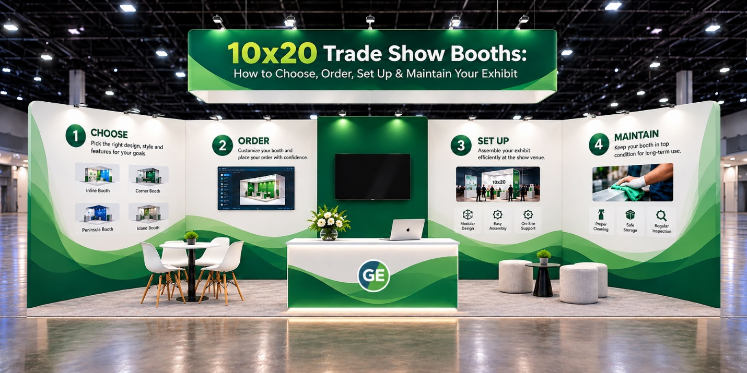

A 10x20 trade show booth gives you 200 square feet of exhibit space, which is large enough to create separate areas for product demonstrations, customer conversations, branding, storage, and lead collection. But choosing the right 10x20 booth is about more than size.
The event itself, your booth location, how many people the booth can accommodate, your goals, shipping requirements, graphics, setup process, and how often you plan to reuse the display can all affect what type of booth makes sense.
This guide walks through those decisions so you can avoid common mistakes and buy a 10x20 trade show booth that works for today's event and future shows.
What You’ll Learn in This Guide
• How to choose a 10x20 booth based on the type of event and your goals
• The different types of trade show booths and configurations
• What to look for in a 10x20 trade show booth design
• How early you should order your booth
• What to check when your booth and graphics arrive
• What to consider for shipping, setup, storage, and future events
• How to maintain fabric graphics and booth components for a longer service life
• What questions to ask before buying from a booth supplier

Start With the Event — Not the Booth
One of the easiest mistakes is choosing a booth first and then trying to make it work.
Start by asking:
What are you trying to accomplish at this event?
Your goal might be to generate sales leads, demonstrate a product, meet existing customers, launch a product, build brand awareness, recruit distributors, or create a space for scheduled meetings. Exhibitor planning guidance recommends defining your objective and target audience before choosing the exhibit.
For example:
If the event is primarily lead generation
Prioritize an open layout that allows attendees to step into the booth easily. Keep your main message visible from the aisle and provide a simple location for conversations and lead capture.
If you’re demonstrating a product
You may need more open floor space, electrical access, monitor placement, shelving, or a dedicated demonstration counter.
If you’re meeting existing customers
A 10x20 booth can be divided into an open presentation area and a semi-private meeting area.
If you’re launching a new product
Your biggest graphic wall, product display, lighting, and demo area should support the launch, not compete with it.
The important point is that the same 10x20 footprint can be designed completely differently depending on the event goal.
Check the Show Floor Before Finalizing Your Booth
A 10x20 booth isn’t the only thing you are buying. You are also buying a position on the show floor.
Before committing to the booth design, review the floor plan and exhibitor manual.
Look for:
• How many sides of your booth are open
• Nearby competitors
• Entrances and exits
• Food areas and lounges
• Presentation or education areas
• Columns or obstructions
• Ceiling height
• Electrical and internet access
• Loading and freight instructions
• Booth height restrictions
Booth location can affect traffic patterns, but there is no universal “best” location for every show. Traffic can vary depending on entrances, session areas, food areas, neighboring exhibitors, and the layout of the venue
That means you should evaluate the actual floor plan instead of simply assuming that the front, center, or back of the hall is always better.
Practical tip: Ask show management for the exhibitor prospectus and current floor plan before finalizing your booth design. The exhibitor manual matters because height limits, shipping procedures, electrical requirements, and deadlines can vary from one event to another.
Understand the Different Types of Trade Show Booths
“Booth type” can mean two different things: the position on the show floor and the way the booth is constructed.
Understanding both will make it much easier to choose the right display.
Booth configurations
Inline or Linear Booth
An inline booth has one aisle-facing side, with neighboring booths on either side.
This is a straightforward choice when you have a traditional row space and want a defined back wall for graphics, displays, shelving, or storage.
A standard 10x20 inline booth gives you a long frontage you can divide into different functional areas.
Corner Booth
A corner booth design has two open sides and sits at the end of a row.
The second aisle-facing side can create additional visibility and gives you more flexibility when designing entrances and traffic flow.
Peninsula Booth
A peninsula is generally open on three sides and shares one side with another booth or boundary. This configuration provides substantially more visual exposure but also requires a design that works from multiple directions.
Island Booth
An island booth is open on all four sides.
These displays offer maximum layout freedom but require you to consider all sides of the structure in the design. Some events allow considerably greater booth heights for island configurations, but the exact rules are show-specific.
Important: Don’t design a booth based solely on the configuration name. Always check the specific event’s rules.

Choose the Construction Style That Fits Your Exhibiting Schedule
A second way to classify booths is by construction.
Portable Displays:
These are designed for mobility and relatively simple setup. They can include pop-up systems, banner displays, and lightweight fabric solutions.
They're useful when portability is the primary requirement.
Modular Booths:
Modular systems use components that can be assembled and sometimes reconfigured for different booth sizes.
This can help companies attending multiple events where the footprint or layout changes from show to show.
Custom Trade Show Booths:
Custom booths are designed around a particular brand, product, floor space, and experience.
They can include custom structures, counters, storage, lighting, monitors, shelving, SEG fabric graphics, meeting areas, and product demonstration zones.
For a company purchasing a 10x20 exhibit, the most important question is not simply “Which booth looks impressive?”
Ask:
Will this booth still be useful after this event?
A modular or reusable design may allow you to replace graphics, change messaging, or rearrange components for future shows.
Design Your 10x20 Booth Around Three Zones
A useful 10x20 layout often becomes easier when you divide the space into three functions:
Figure 1 Trade show booth zones

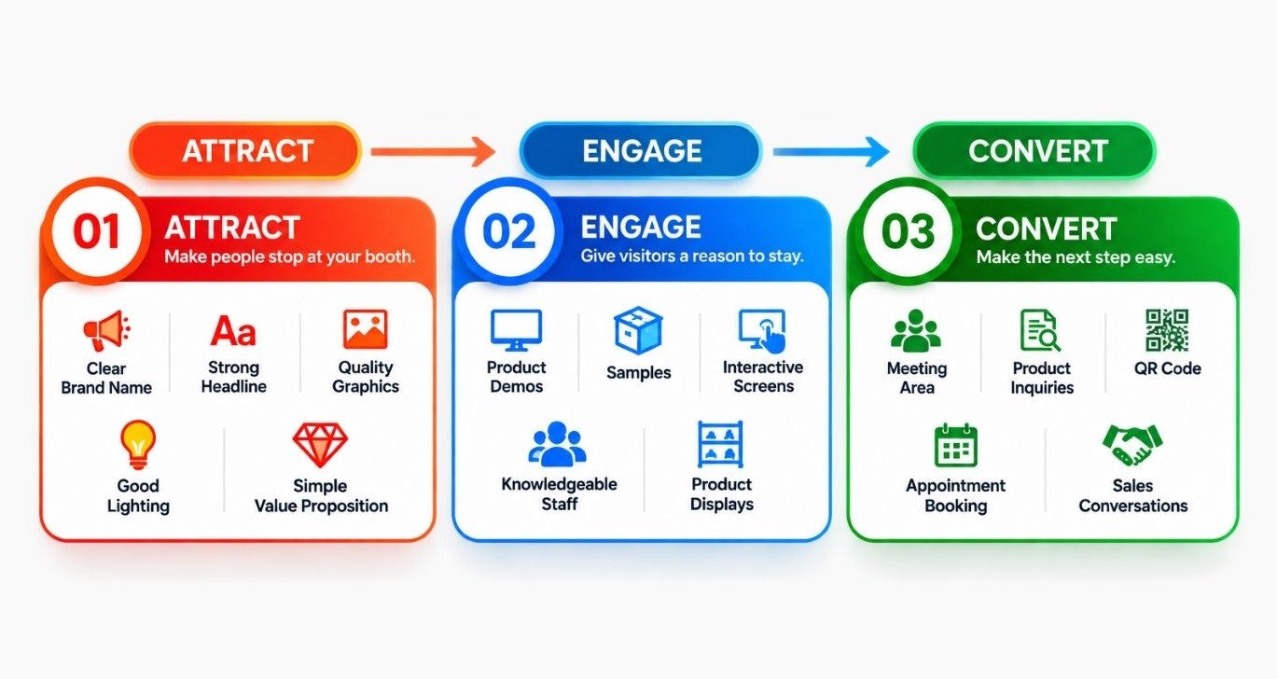

Don’t Forget Storage
One of the most overlooked elements of a trade show booth is storage.
Without a designated storage area, boxes, bags, packaging materials, jackets, marketing supplies, cables, and personal belongings can quickly become visible.
A 10x20 booth provides enough space to incorporate storage without sacrificing the entire visitor experience.
Consider where you will keep:
• Extra brochures
• Product samples
• Personal items
• Packaging
• Spare graphics
• Cleaning supplies
• Electrical accessories
• Giveaways
Good storage isn’t just about appearance. It can make the booth easier for the team to operate throughout a busy event.

Choose Graphics for the Viewing Distance
Your graphics should work from several distances.
From across the aisle, someone should recognize your company and understand what you offer.
Closer to the booth, they can see supporting information.
In the conversation area, a salesperson can provide detailed information through a brochure, product sheet, monitor, or QR code.
For fabric exhibits, proper handling matters, too. Exhibitor guidance recommends keeping fabrics clean during setup and dismantling, handling them with clean hands or gloves, and following the manufacturer’s specific cleaning instructions.
How Early Should You Order a 10x20 Trade Show Booth?
This is one of the most important questions to answer before buying.
There is no single universal lead time because production, graphics, booth complexity, shipping method, show location, and event deadlines can all be different.
However, don’t plan around the show opening date.
A better target
For peace of mind, try to have the complete booth in your possession and checked at least a couple of weeks before the event.
That gives you time to:
• Open all shipping cases
• Confirm that every component has arrived
• Check the frame and hardware
• Inspect printed graphics
• Confirm dimensions
• Check for print defects or damage
• Assemble the booth at least once when practical
• Test lighting and electrical accessories
• Confirm that counters, shelves, and accessories are present
• Resolve missing or damaged components
• Repack everything for transportation
This buffer is extremely valuable. You don’t want the first time you see your finished 10x20 booth to be on the morning of the show.
My recommended planning approach:
Before ordering: confirm your booth dimensions, configuration, event rules, and artwork requirements.
During production: approve the design carefully and confirm exactly what is included.
At least a couple of weeks before the event: have the booth delivered and inspect the complete package.
Before shipping to the venue: verify the show’s advance-warehouse or direct-delivery instructions.
Before show opening: assemble, test and inspect everything.
That small amount of extra planning can eliminate a huge amount of stress.
Use a “Received Complete” Checklist
When your booth arrives, don’t just look at the boxes and assume everything is there.
Create a simple checklist based on the supplier’s packing list.
Check:
Figure 2 checklist
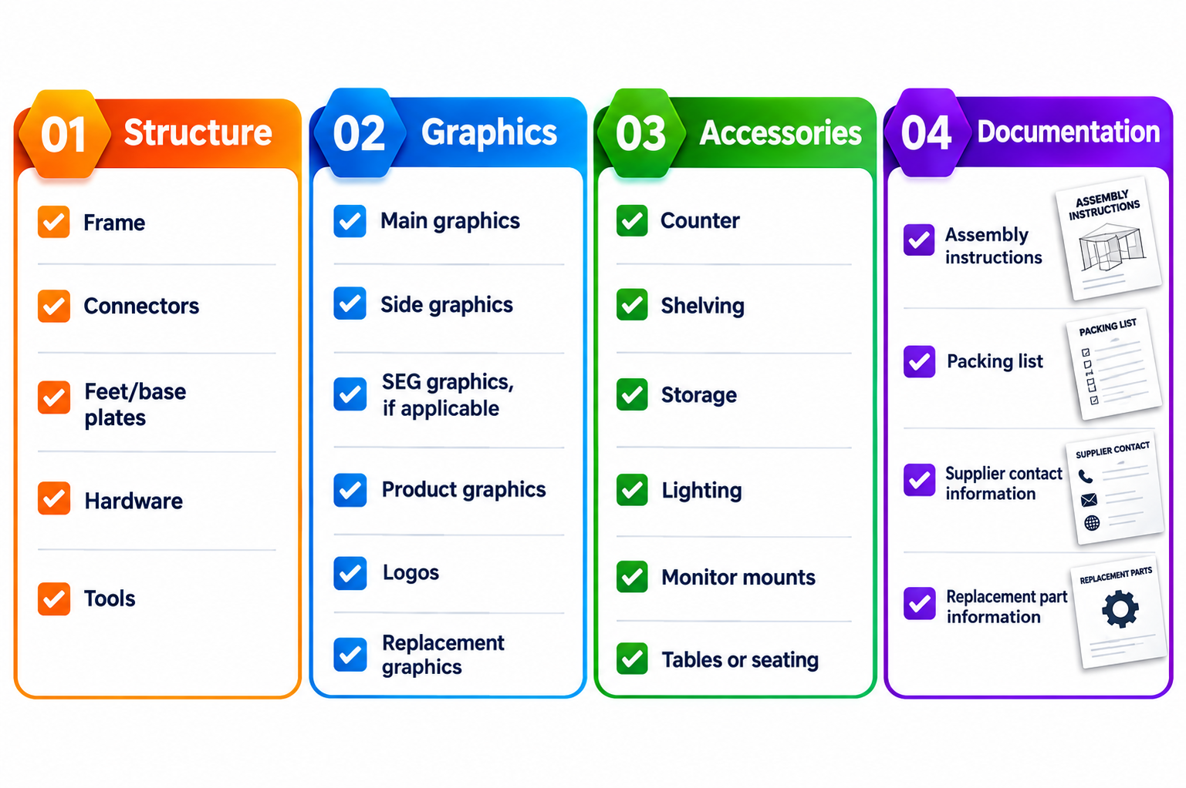This is one of the easiest ways to identify a problem while you still have time to fix it.

Always Check the Graphics Before the Event
A booth structure can be perfect, but the graphics can have the real problem.
Before the show, inspect the graphics for:
• Incorrect dimensions
• Cropping
• Color differences
• Spelling mistakes
• Missing logos
• Damage
• Creases
• Incorrect graphic placement
• Wrong quantity
For a large custom 10x20 trade show display, don’t wait until installation day to discover that one important graphic panel was printed incorrectly.
Ask your supplier to approve the artwork before production, and keep the final approved artwork on file.

Make the Booth Easy for Your Team to Work In
A good trade show booth isn’t just designed for visitors. It needs to work for the people staffing it.
Think about:
• Where staff will stand
• Where bags and personal items go
• Where leads are captured
• Where sales conversations take place
• Where products are demonstrated
• Where spare materials are stored
• How staff enter and exit the booth
Avoid filling every square foot with furniture.
Your visitors need room to move, and your staff needs room to work.

What to Do After the Trade Show
This is where you can significantly extend a booth's lifespan.
Don’t dismantle everything and throw it into a storage room immediately after the show.

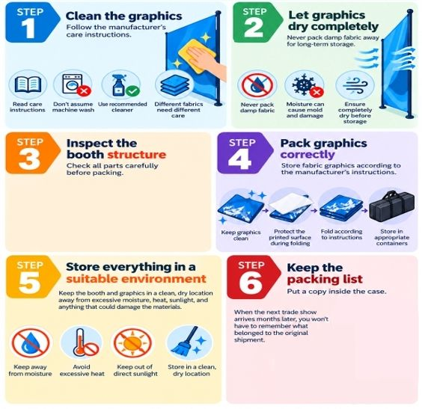

Don’t Wait Until the Next Show to Repair Something
A very practical habit is to inspect the booth immediately after each event.
Exhibitor maintenance guidance recommends identifying damage early and arranging cleaning, repairs, or touch-ups before returning the exhibit to storage.
Create a simple post-show report:
What was damaged?
What needs cleaning?
What needs replacing?
What should be changed for the next show?
This turns booth maintenance into a routine, not an emergency.

Build Your 10x20 Booth for Future Events:
Your first event doesn’t have to be the last time you use the booth.
When choosing a system, consider whether you can:
• Replace graphics without replacing the frame
• Change the messaging
• Move shelves or counters
• Add new accessories
• Reconfigure storage
• Add lighting
• Use different graphics for different products
• Adapt the booth to another 10x20 event
Reusable fabric and modular systems can be especially useful for companies exhibiting at multiple events because you can pack and reuse components and graphics.
This is one reason the cheapest initial quote isn’t always the only number worth considering.
Think about the cost per event over the booth's life, not just the purchase price.
Questions to Ask Before Buying a 10x20 Trade Show Booth
Before placing an order, ask the supplier:
What’s included?
Does the price include the frame, graphics, hardware, cases, lighting, counters, shelving, and accessories?
Are the graphics included?
Clarify exactly how many graphics are included and what material will be used.
Is the booth reusable?
Can you replace graphics without buying another complete booth?
How long is production?
Get the production timeline in writing.
What happens if something arrives damaged?
Ask how damaged or missing components are handled.
Is a design proof included?
Make sure you approve the artwork before printing.
How will everything be packed?
Ask about shipping cases and protection.
What happens after the event?
Ask for recommended cleaning, packing, and 10x20 booth storage solutions for instructions.

Frequently Asked Questions About 10x20 Trade Show Booths
How much space does a 10x20 trade show booth provide?
A 10x20 booth provides 200 square feet of exhibit space.
What is the difference between a 10x20 inline and corner booth?
An inline booth generally has one aisle-facing side, while a corner configuration provides exposure to two aisles. The exact rules and dimensions can vary by event.
How far in advance should I order a 10x20 trade show booth?
There is no single deadline for every supplier or show. A safer approach is to plan early enough to have the complete booth in your possession and inspected at least a couple of weeks before the event, while also meeting the show’s service and shipping deadlines. Current show schedules from GES demonstrate that advance-shipping and exhibit-service deadlines can occur well before move-in.
Should I test my booth before the trade show?
Yes. A practice assembly lets you identify missing hardware, incorrect graphics, assembly problems, and other issues before arriving at the venue.
How should I store fabric trade show graphics?
Clean and completely dry the graphics first, then follow the supplier’s specific folding, rolling and storage instructions. Different fabrics have different care requirements.
Can a 10x20 booth be reused?
Many modular and fabric-based systems are designed for reuse. Graphics, accessories and layouts can sometimes be changed without replacing the entire structure.

Final Thoughts
Buying a 10x20 trade show booth should not be treated as simply buying a large backdrop.
Start with the event.
Understand who will attend, what you want visitors to do, where your booth sits, what the venue allows, how the booth will be shipped, and how you will use it after the event.
Then choose the booth structure, graphics, lighting, storage and accessories around those requirements.
Most importantly, don’t wait until show day for the first inspection. Having your booth delivered, checked, assembled and confirmed complete a couple of weeks ahead of the event gives you time to correct problems and arrive at the show with much greater peace of mind. Freeman’s exhibitor checklist likewise recommends confirming shipments and testing booth technology before the show opens.
A well-planned booth doesn’t just look good on opening morning. It should be easy to ship, easy to assemble, practical for your staff, reusable for future events, and simple to maintain.
Planning a 10x20 trade show booth? Share your booth size, event date, booth location and artwork requirements with your supplier before production. A good supplier should help you determine the layout and provide a design proof before anything goes to print.
Title: 10x20 Trade Show Booths: How to Choose, Order & Maintain One for Your Event
Meta Description:
Learn how to choose a 10x20 trade show booth based on your event, booth type, layout, ordering timeline, shipping, setup, graphics and long-term maintenance.

A 10x20 trade show booth gives you 200 square feet of exhibit space, which is large enough to create separate areas for product demonstrations, customer conversations, branding, storage, and lead collection. But choosing the right 10x20 booth is about more than size.
The event itself, your booth location, how many people the booth can accommodate, your goals, shipping requirements, graphics, setup process, and how often you plan to reuse the display can all affect what type of booth makes sense.
This guide walks through those decisions so you can avoid common mistakes and buy a 10x20 trade show booth that works for today's event and future shows.
What You’ll Learn in This Guide
- How to choose a 10x20 booth based on the type of event and your goals
- The different types of trade show booths and configurations
- What to look for in a 10x20 trade show booth design
- How early you should order your booth
- What to check when your booth and graphics arrive
- What to consider for shipping, setup, storage, and future events
- How to maintain fabric graphics and booth components for a longer service life
- What questions to ask before buying from a booth supplier
Start With the Event — Not the Booth
One of the easiest mistakes is choosing a booth first and then trying to make it work.
Start by asking:
What are you trying to accomplish at this event?
Your goal might be to generate sales leads, demonstrate a product, meet existing customers, launch a product, build brand awareness, recruit distributors, or create a space for scheduled meetings. Exhibitor planning guidance recommends defining your objective and target audience before choosing the exhibit.
For example:
If the event is primarily lead generation
Prioritize an open layout that allows attendees to step into the booth easily. Keep your main message visible from the aisle and provide a simple location for conversations and lead capture.
If you’re demonstrating a product
You may need more open floor space, electrical access, monitor placement, shelving, or a dedicated demonstration counter.
If you’re meeting existing customers
A 10x20 booth can be divided into an open presentation area and a semi-private meeting area.
If you’re launching a new product
Your biggest graphic wall, product display, lighting, and demo area should support the launch, not compete with it.
The important point is that the same 10x20 footprint can be designed completely differently depending on the event goal.
Check the Show Floor Before Finalizing Your Booth
A 10x20 booth isn’t the only thing you are buying. You are also buying a position on the show floor.
Before committing to the booth design, review the floor plan and exhibitor manual.
Look for:
- How many sides of your booth are open
- Nearby competitors
- Entrances and exits
- Food areas and lounges
- Presentation or education areas
- Columns or obstructions
- Ceiling height
- Electrical and internet access
- Loading and freight instructions
- Booth height restrictions
Booth location can affect traffic patterns, but there is no universal “best” location for every show. Traffic can vary depending on entrances, session areas, food areas, neighboring exhibitors, and the layout of the venue
That means you should evaluate the actual floor plan instead of simply assuming that the front, center, or back of the hall is always better.
Practical tip: Ask show management for the exhibitor prospectus and current floor plan before finalizing your booth design. The exhibitor manual matters because height limits, shipping procedures, electrical requirements, and deadlines can vary from one event to another.
Understand the Different Types of Trade Show Booths
“Booth type” can mean two different things: the position on the show floor and the way the booth is constructed.
Understanding both will make it much easier to choose the right display.
Booth configurations
Inline or Linear Booth:
An inline booth has one aisle-facing side, with neighboring booths on either side.
This is a straightforward choice when you have a traditional row space and want a defined back wall for graphics, displays, shelving, or storage.
A standard 10x20 inline booth gives you a long frontage you can divide into different functional areas.
Corner Booth:
A corner booth designhas two open sides and sits at the end of a row.
The second aisle-facing side can create additional visibility and gives you more flexibility when designing entrances and traffic flow.
Peninsula Booth:
A peninsula is generally open on three sides and shares one side with another booth or boundary. This configuration provides substantially more visual exposure but also requires a design that works from multiple directions.
Island Booth:
An island booth is open on all four sides.
These displays offer maximum layout freedom but require you to consider all sides of the structure in the design. Some events allow considerably greater booth heights for island configurations, but the exact rules are show-specific.
Important: Don’t design a booth based solely on the configuration name. Always check the specific event’s rules.
Choose the Construction Style That Fits Your Exhibiting Schedule:
A second way to classify booths is by construction.
Portable Displays:
These are designed for mobility and relatively simple setup. They can include pop-up systems, banner displays, and lightweight fabric solutions.
They're useful when portability is the primary requirement.
Modular Booths:
Modular systems use components that can be assembled and sometimes reconfigured for different booth sizes. This can help companies attending multiple eventswhere the footprint or layout changes from show to show.
Custom Trade Show Booths:
Custom booths are designed around a particular brand, product, floor space, and experience.
They can include custom structures, counters, storage, lighting, monitors, shelving, SEG fabric graphics, meeting areas, and product demonstration zones.
For a company purchasing a 10x20 exhibit, the most important question is not simply “Which booth looks impressive?”
Ask:
Will this booth still be useful after this event?
A modular or reusable design may allow you to replace graphics, change messaging, or rearrange components for future shows.
Design Your 10x20 Booth Around Three Zones
A useful 10x20 layout often becomes easier when you divide the space into three functions:
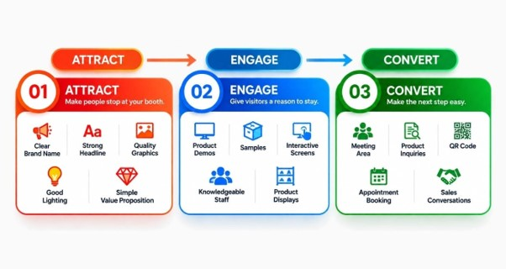
Don’t Forget Storage
One of the most overlooked elements of a trade show booth is storage.
Without a designated storage area, boxes, bags, packaging materials, jackets, marketing supplies, cables, and personal belongings can quickly become visible.
A 10x20 booth provides enough space to incorporate storage without sacrificing the entire visitor experience.
Consider where you will keep:
- Extra brochures
- Product samples
- Personal items
- Packaging
- Spare graphics
- Cleaning supplies
- Electrical accessories
- Giveaways
Good storage isn’t just about appearance. It can make the booth easier for the team to operate throughout a busy event.
Choose Graphics for the Viewing Distance
Your graphics should work from several distances.
From across the aisle, someone should recognize your company and understand what you offer.
Closer to the booth, they can see supporting information.
In the conversation area, a salesperson can provide detailed information through a brochure, product sheet, monitor, or QR code.
For fabric exhibits, proper handling matters, too. Exhibitor guidance recommends keeping fabrics clean during setup and dismantling, handling them with clean hands or gloves, and following the manufacturer’s specific cleaning instructions.
How Early Should You Order a 10x20 Trade Show Booth?
This is one of the most important questions to answer before buying.
There is no single universal lead time because production, graphics, booth complexity, shipping method, show location, and event deadlines can all be different.
However, don’t plan around the show opening date.
A better target
For peace of mind, try to have the complete booth in your possession and checked at least a couple of weeks before the event.
That gives you time to:
- Open all shipping cases
- Confirm that every component has arrived
- Check the frame and hardware
- Inspect printed graphics
- Confirm dimensions
- Check for print defects or damage
- Assemble the booth at least once when practical
- Test lighting and electrical accessories
- Confirm that counters, shelves, and accessories are present
- Resolve missing or damaged components
- Repack everything for transportation
This buffer is extremely valuable. You don’t want the first time you see your finished 10x20 booth to be on the morning of the show.
My recommended planning approach:
Before ordering: confirm your booth dimensions, configuration, event rules, and artwork requirements.
During production: approve the design carefully and confirm exactly what is included.
At least a couple of weeks before the event: have the booth delivered and inspect the complete package.
Before shipping to the venue: verify the show’s advance-warehouse or direct-delivery instructions.
Before show opening: assemble, test and inspect everything.
That small amount of extra planning can eliminate a huge amount of stress.
Use a “Received Complete” Checklist
When your booth arrives, don’t just look at the boxes and assume everything is there.
Create a simple checklist based on the supplier’s packing list.
This is one of the easiest ways to identify a problem while you still have time to fix it.
Always Check the Graphics Before the Event
A booth structure can be perfect, but the graphics can have the real problem.
Before the show, inspect the graphics for:
- Incorrect dimensions
- Cropping
- Color differences
- Spelling mistakes
- Missing logos
- Damage
- Creases
- Incorrect graphic placement
- Wrong quantity
For a large custom 10x20 trade show display, don’t wait until installation day to discover that one important graphic panel was printed incorrectly.
Ask your supplier to approve the artwork before production, and keep the final approved artwork on file.
Make the Booth Easy for Your Team to Work In
A good trade show booth isn’t just designed for visitors. It needs to work for the people staffing it.
Think about:
- Where staff will stand
- Where bags and personal items go
- Where leads are captured
- Where sales conversations take place
- Where products are demonstrated
- Where spare materials are stored
- How staff enter and exit the booth
- Avoid filling every square foot with furniture.
Your visitors need room to move, and your staff needs room to work.
What to Do After the Trade Show
This is where you can significantly extend a booth's lifespan.
Don’t dismantle everything and throw it into a storage room immediately after the show.
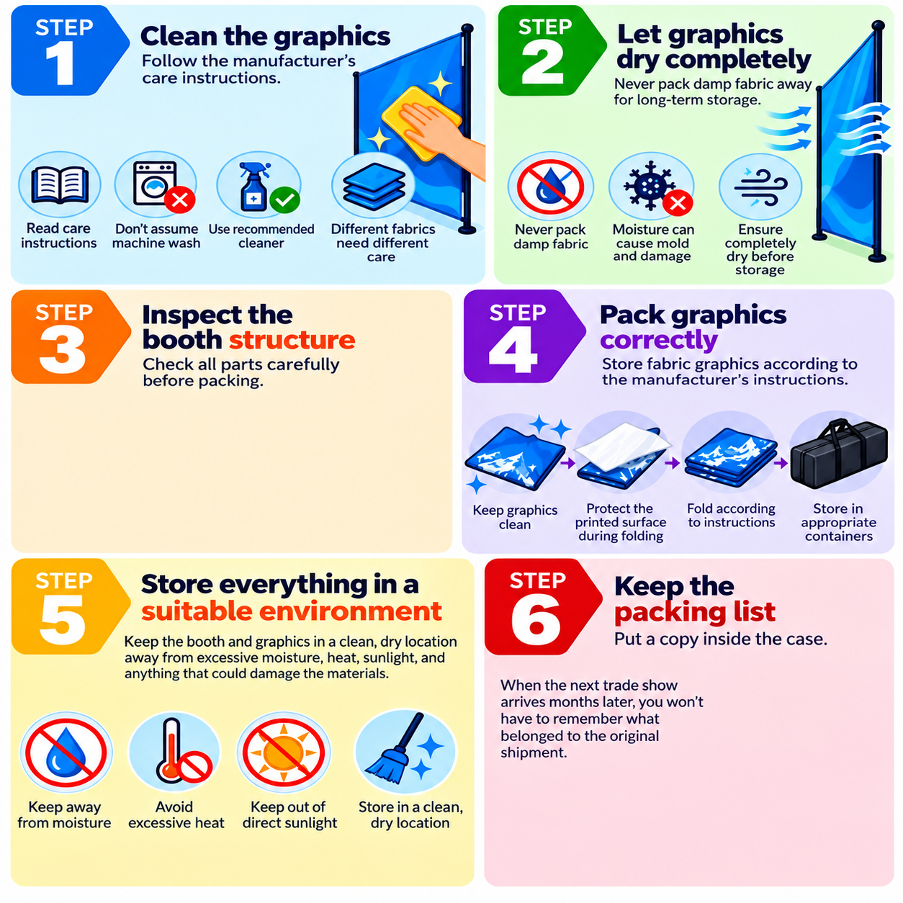
Don’t Wait Until the Next Show to Repair Something
A very practical habit is to inspect the booth immediately after each event.
Exhibitor maintenance guidance recommends identifying damage early and arranging cleaning, repairs, or touch-ups before returning the exhibit to storage.
Create a simple post-show report:
What was damaged?
What needs cleaning?
What needs replacing?
What should be changed for the next show?
This turns booth maintenance into a routine, not an emergency.
Build Your 10x20 Booth for Future Events:
Your first event doesn’t have to be the last time you use the booth.
When choosing a system, consider whether you can:
- Replace graphics without replacing the frame
- Change the messaging
- Move shelves or counters
- Add new accessories
- Reconfigure storage
- Add lighting
- Use different graphics for different products
- Adapt the booth to another 10x20 event
Reusable fabric and modular systems can be especially useful for companies exhibiting at multiple events because you can pack and reuse components and graphics.
This is one reason the cheapest initial quote isn’t always the only number worth considering.
Think about the cost per event over the booth's life, not just the purchase price.
Questions to Ask Before Buying a 10x20 Trade Show Booth
Before placing an order, ask the supplier:
What’s included?
Does the price include the frame, graphics, hardware, cases, lighting, counters, shelving, and accessories?
Are the graphics included?
Clarify exactly how many graphics are included and what material will be used.
Is the booth reusable?
Can you replace graphics without buying another complete booth?
How long is production?
Get the production timeline in writing.
What happens if something arrives damaged?
Ask how damaged or missing components are handled.
Is a design proof included?
Make sure you approve the artwork before printing.
How will everything be packed?
Ask about shipping cases and protection.
What happens after the event?
Ask for recommended cleaning, packing, and 10x20 booth storage solutions for instructions.

Final Thoughts
Buying a 10x20 trade show booth should not be treated as simply buying a large backdrop.
Start with the event.
Understand who will attend, what you want visitors to do, where your booth sits, what the venue allows, how the booth will be shipped, and how you will use it after the event.
Then choose the booth structure, graphics, lighting, storage and accessories around those requirements.
Most importantly, don’t wait until show day for the first inspection. Having your booth delivered, checked, assembled and confirmed complete a couple of weeks ahead of the event gives you time to correct problems and arrive at the show with much greater peace of mind. Freeman’s exhibitor checklist likewise recommends confirming shipments and testing booth technology before the show opens.
A well-planned booth doesn’t just look good on opening morning. It should be easy to ship, easy to assemble, practical for your staff, reusable for future events, and simple to maintain.
Planning a 10x20 trade show booth? Share your booth size, event date, booth location and artwork requirements with your supplier before production. A good supplier should help you determine the layout and provide a design proof before anything goes to print.

